**INTRANET http://idtbintranetdev/**

**ECS http://idtbecsapexdev/**

**TO BE –FKD Service System**

**Document Information**

|  |  |
| --- | --- |
| File Name | **TO BE – FKD Service System)** |
|  |  |
|  |  |

**Change Records**

| Date | Author | Version | Change Reference |
| --- | --- | --- | --- |
|  |  |  |  |
| 21 April 2025 | Nurhidayanto | 1.0 |  |
|  | Ambar Kusuma |  |  |
|  | Novi Nirwanto |  |  |
|  |  |  |  |
|  |  |  |  |

**Reviewer**

| Name | Position |
| --- | --- |
|  |  |
| Imam Yogi W | Section Head GA – BCF |
| Krisna Raisandi | Section Head IT Digital Improvement I |
|  |  |
|  |  |
|  |  |

Table of contents

1 Objective/Scope 2

1.1 Objective 2

1.2 Scope 2

2 To Be Business Process Flow 3

2.1 Business Flow 3

2.2 Business Flow Description 4

3 Business Improvement (As Is vs To Be) 4

Approval 9

Objective/Scope

## Objective

Create new company vehicle facilities (FKD Service System) for SIMINTRANET users at PT. SIM/SIS that can provide:

1. FKD users to submit paperless service request with digital workflow to GA BCF/HR Location from desktop and mobile application.
2. Stakeholder system (FKD Users, GA BCF/HR Location can monitor and control their periodic vehice service from application dashboard.
3. Streamlining work order request so it can be delivered ontime to the Official Vehicle Workshop

## Scope

The scope of this system development is to create FKD submission and approval system, dashboard and notification for monitoring, and integrated work order to Vehicle Workshop system

To Be Business Process Flow

## Business Flow

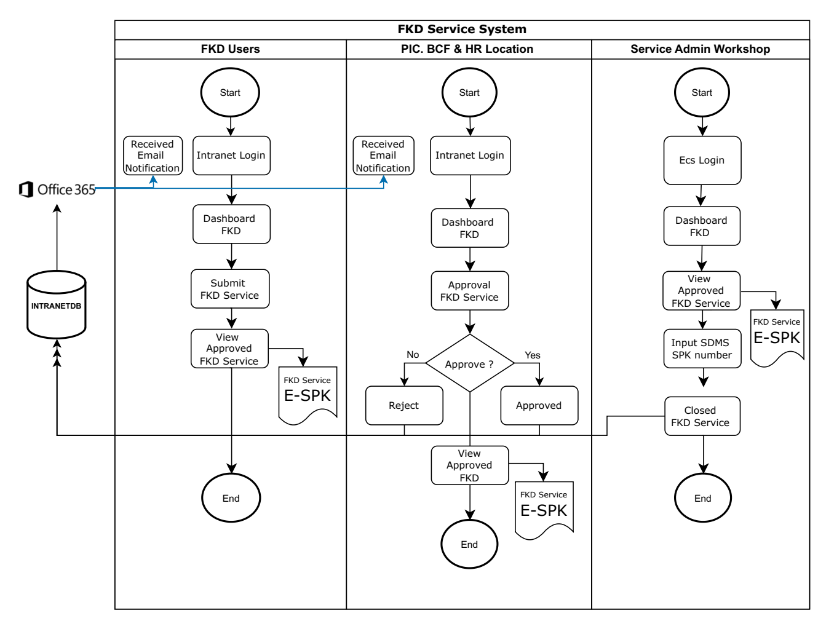

## Business Flow Description

1. FKD Users must login to Intranet portal and access to Dashboard FKD
2. FKD Users must create, entry then submit FKD Service request to the system
3. System send email FKD Service request notification to PIC. BCF GA/HR Location
4. PIC. GA BCF/HR Location received email notification regarding FKD Service request
5. PIC. GA BCF/HR Location must login to Intranet portal and access Dashboard FKD
6. PIC. GA BCF/HR Location open FKD Service request then make decision whether approved or rejected
7. System send email notification to FKD Users
8. FKD Users received email approved FKD Service notification.
9. FKD Users view approved FKD Service and then see SIM/SIS Electronic SPK (E-SPK)
10. PIC. GA BCF/HR Location view approved FKD Service and then see Electronic SPK (E-SPK)
11. Service Admin Workshop must login to ECS portal and access to Dashboard FKD
12. Service Admin Workshop view approved FKD Service
13. Service Admin Workshop input SDMS SPK number on approved FKD Service
14. Service Admin Workshop then closed FKD Service

# Business Improvement (As Is vs To Be)

|  |  |  |  |
| --- | --- | --- | --- |
| **No** | **Description** | **As Is** | **To Be** |
| **1** | Initial service request form | * Still using paper form and hand sign approval * Generate from desktop application | * Using paperless and digital submission and approval workflow * Available on desktop and mobile application |
| **2** | Monitoring Dashboard | Not available | Available on Intranet (desktop) and Ecs (mobile) dashboard |
| **3** | Notification | Not available | Send automatically to users email |

## Sample Screen

3.1.1 Login Intranet and Application Icon

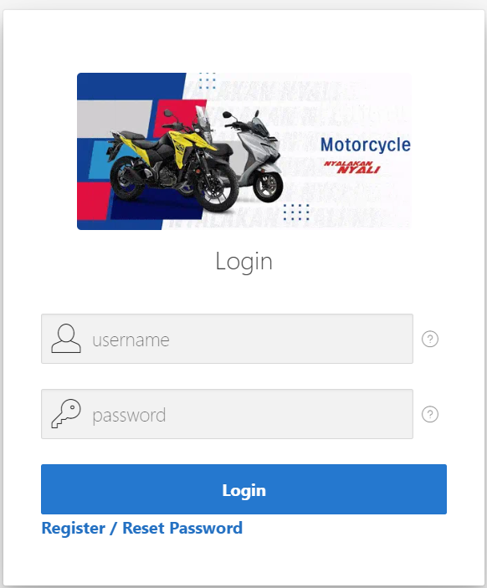

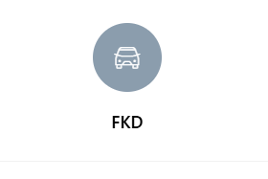

3.1.2. Main Menu FKD System

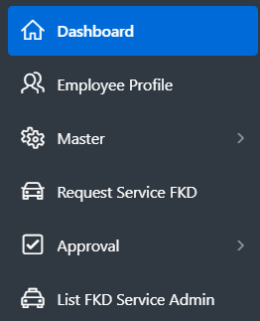 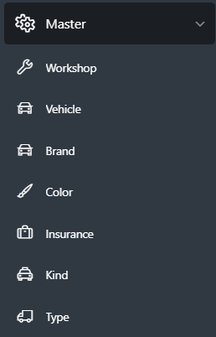

3.1.3. Dashboard FKD Service

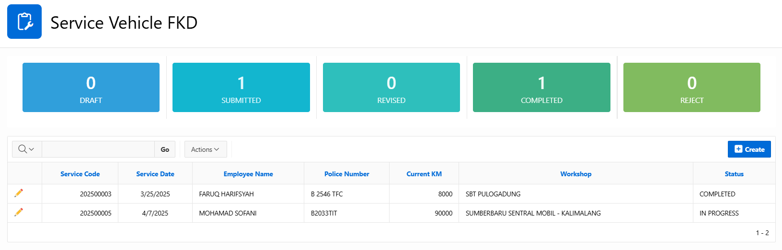

3.1.4. Form Service FKD

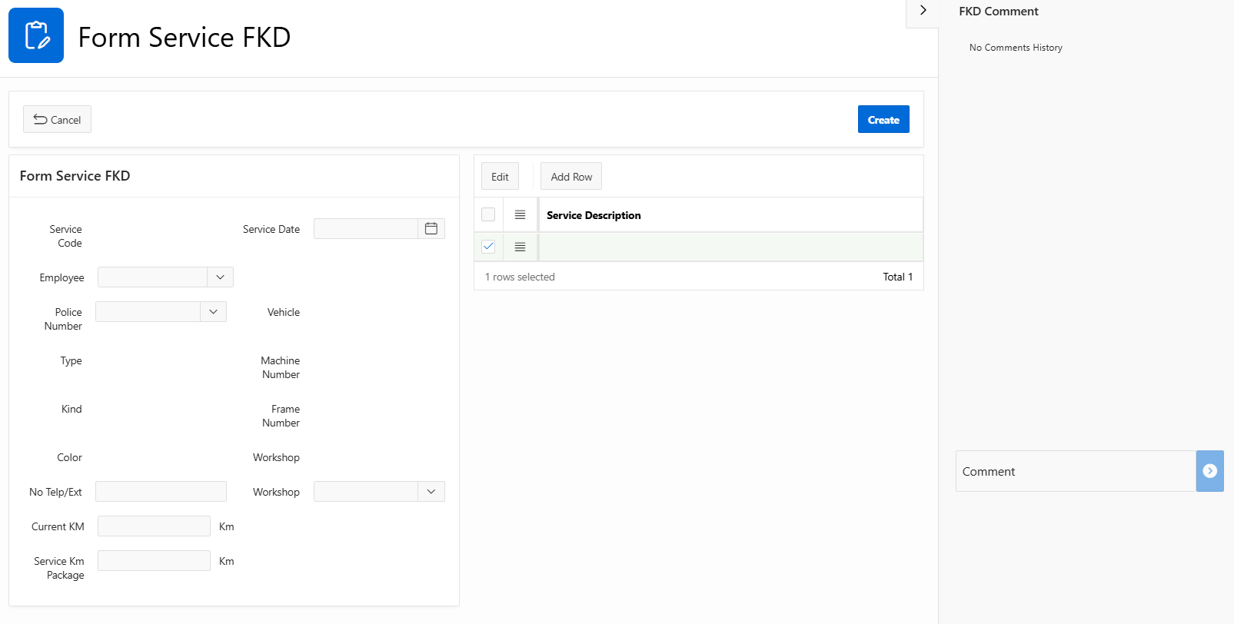

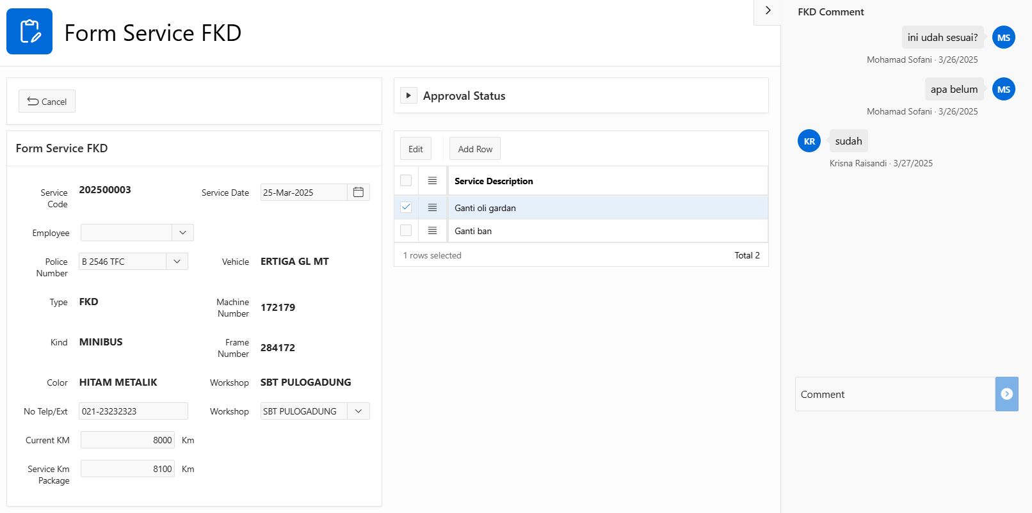

3.1.5. Login ECS Portal and Application Icon

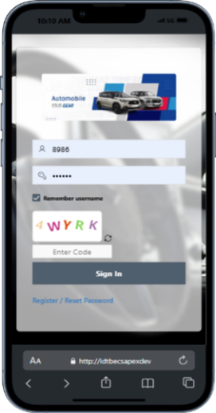 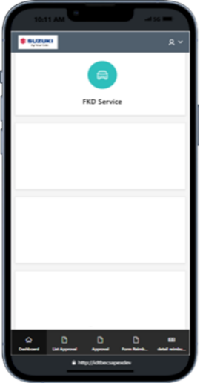 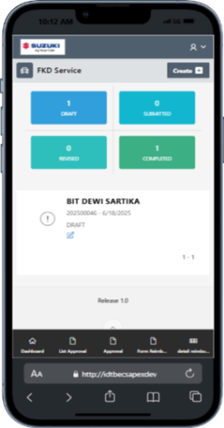 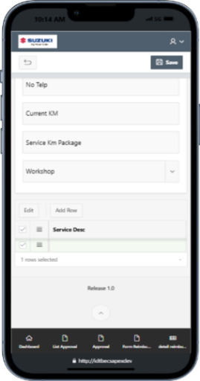

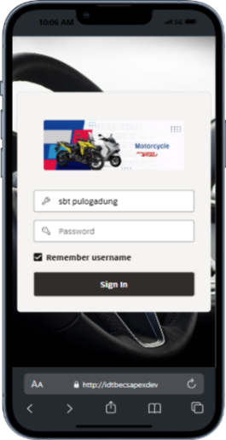 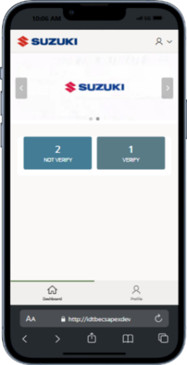 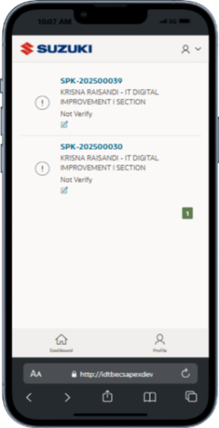

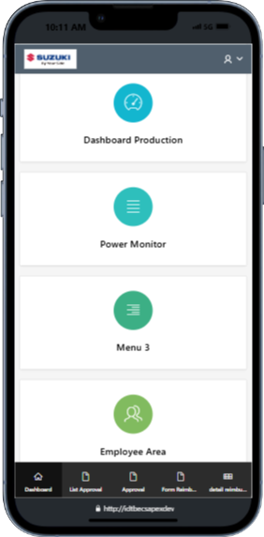

3.1.6. Email Notification

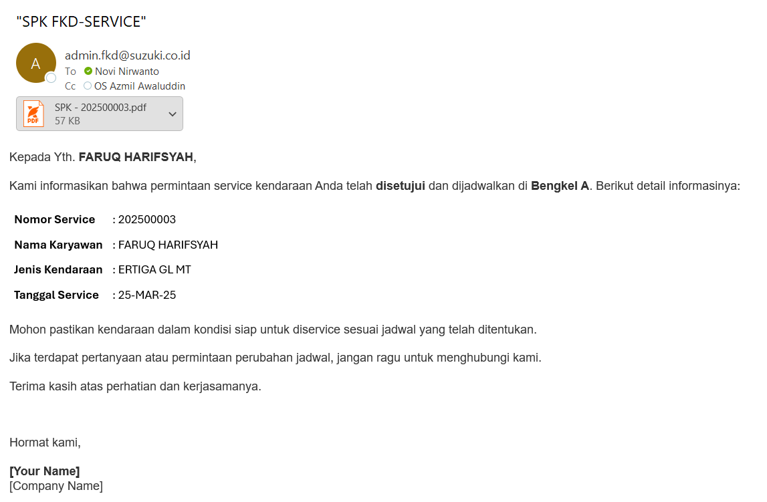

## Design database

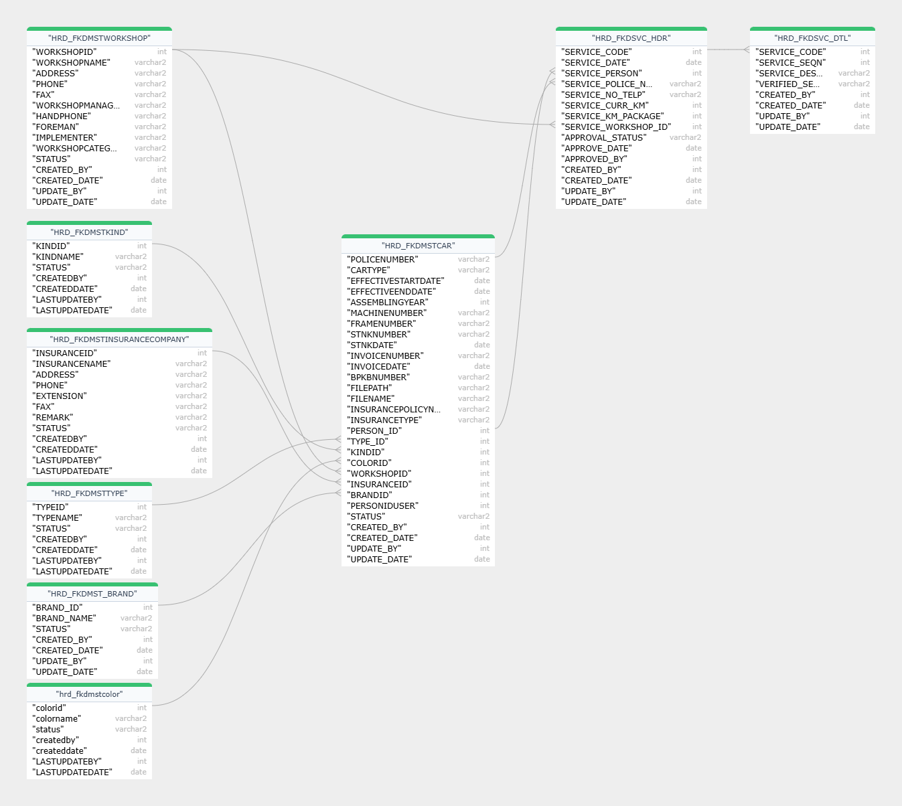

# Time Schedule

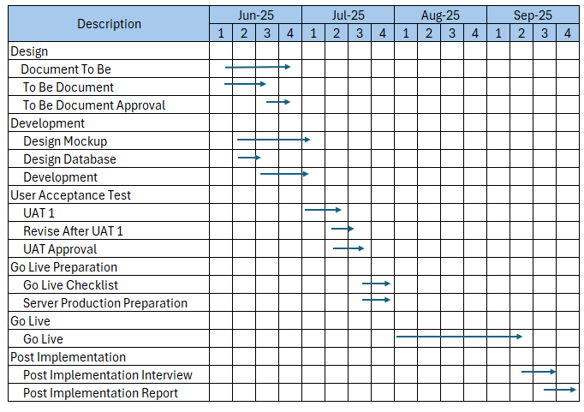

Approval

After reviewing the as is business process analysis, we, user BCF section team agree to use this document for next process (Development).

**User - GA Department**

|  |  |  |
| --- | --- | --- |
| **Approval** | **Approval** | **Approval** |
| Nurhidayanto  Staff GA BCF Section | Ambar Kusumaningayu  Staff GA BCF Section | Imam Yogi Wibowo  Section Head GA BCF Section |
|  | Gunardi Prakosa  Dept. Head General Affair |  |

IT Department

|  |  |  |  |
| --- | --- | --- | --- |
| **Approval** | | | |
|  |  |  |  |
|  |  |  |  |
|  |  |  |  |
|  |  |  |  |
|  |  |  |  |
| Novi Nirwanto | Mohamad Sofani | | Krisna Raisandi |
| Staff IT Digital Improvement I Section | Staff IT Digital Improvement I Section | | Section Head  IT Digital Improvement I Section |
|  |  |  |  |
|  |  |  |  |
|  |  |  |  |
|  |  |  |  |
|  |  |  |  |
|  | Hitoshi Sugita | |  |
|  | Dept.Head IT Department | |  |